Questions générales :

Qu’elle est l’influence du creux de Mackenzie?

Quelles seront les zones d’études prisent en compte dans la coupe stratigraphique?

Comment le gaz est capté à l’intérieur du pergélisol?

Qu’elles sont les relations stratigraphiques entre le pergélisol et les autres composés géologiques?

Qu’elle est la zone d’étendu du pergélisol? Est-il plus présent sur le littoral ou bien est-il plutôt marin?

Quels sont les effets de la salinité, de la glace, de l’eau et de la température sur le comportement des ondes sismiques dans le pergélisol?

Sub-sea permafrost :

Peu contenir de la glace ou pas.

Il n’y pas a de glace sur le dessus du permafrost la majeur partie du temps

Il y a une relation entre le dégel du permafrost et son niveau de submertion

Le sel réduit la quantité de glace dans le sol et réduit l’équilibre entre la température et la quantité de glace.

Quelques endroits de la mer de Beaufort contient des permafrost riche en glace et eau salé.

Facteur qui influence le permafrost : geologie, meteorologie, oceanographie, hydrologie, cryologie

Climate change and the permafrost carbon feedback

Activités microbiennes qui produisent le méthane

Les thermokasts provoquent la fonde rapide du pergélisol et c’est régional

Présence de permafrost sous les océans et le ch4 est prisonnier en dessous en raison de la glace ou du pergélisol.

Certaines régions du nord de la sibérie on vu les températures augmenter de 2.1 degres

Activation of old carbon by erosion of coastal and subsea permafrost in Arctic Siberia

The influence of clay-sized particles on seismic velocity for Canadian arctic permafrost

Les ondes compressives du pergélisol sont fonctions de la porosité remplie d’eau et est indépendante de la porosité original, la teneur en argile ainsi que la température.

Il y a formation de glace dans les pores lorsque la température va sous les zéro degrés

L’apport de salinité dans l’eau vient réduire le taux de formation de glace sous les zéros degrés

Fraction de glace dans le pergélisol pour les roches consolidées de pergélisol :

$$\frac{1}{Vp}= \frac{φ\left(1-Fj\right)}{V1}+\frac{φFj}{Vi}+\frac{1-φ}{Vm}$$

Vp : P-wave velocity in permafrost

Φ : Porosity of permafrost

V1 : P-wave velocity in pore water

Vi : P-wave velocity in ice

Vm : P-wave velocity in the matrix

Fi : fraction of ice in the pore

La fraction de glace contenue dans le pergélisol joue un facteur essentiel dans la vélocité des ondes de compression sismique.

La porosité quant à elle, joue un rôle moins important, mais tout de même non négligeable.

La vélocité des ondes sismiques en compression (Vp) varient en fonction de la porosité et de la fraction de glace comme le démontre l’équation suivante :

$$Vp= φ\left(1-Fi\right)$$

Some seismic, electrical, and thermal properties of sub-seabottom permafrost from the Beaufort Sea

En moyenne, la température du pergélisol sous-marin est plus élevée que le pergélisol littoral. L’article considère dans le résumé que l’eau contenue dans le pergélisol de la zone de Beaufort est faiblement saline puisque les résultats concordent assez bien dans les résultats effectués dans des zones faiblement saline.

La vitesse des ondes sismique en compression est plus rapide dans le sable que dans l’argile.

La résistivité du permafrost diminue drastiquement lorsque la salinité de l’eau dans les pores augmente.

Au final, le pergélisol sous la mer de Beaufort ce comporte sensiblement comme le pergélisol côtier. Toutefois, il existe certaines anomalies locales où la salinité du pergélisol augmente drastiquement.

Effects of submarine groundwater discharge on the present-day extent of relict submarine permafrost and gas hydrate stability on the Beaufort Sea continental shelf

Les sédiments qui sont peu gelés sont plus difficilement détectables puisqu’ils illustrent moins de variation intense de changement de vitesse (1524 and 1981 m s−1). Tandis que les sédiments qui sont plus gelés ont des valeurs variant de 2438 and 4267 m s−1.

Donc les sédiments non gelés sont considérés entre 1700 à 2100 m/s tandis que les gelés ont des vitesses supérieurs à 2300 m/s.

Article à relire pour information générale…

Electrical and seismic response of saline permafrost soil during freeze - Thaw transition

À des temperatures supérieures à 0 degre, les propriétés mécaniques du pergélisol sont de beaucoup réduite. Cette réduction est d’autant plus importante dans les sols contenant plus de salinité.

La résistivité du sol gelée lui une droite linéaire négative qui indique que plus le sol est gelée, plus sa résistivité sera élevée. Arrivé au point de congélation, la résistivité diminue toujours, mais la pente négative est presque nulle. Ainsi, la résistivité tend à se stabiliser.

L’atténuation des ondes de cisaillement tend à augmenter lorsque la température du pergélisol augmente. Ainsi, la glace dans l’espace dans vide joue un facteur clé dans le transport dans ondes sismique S.

Les modules G et E régressent linéairement lorsque la température du pergélisol augmente. Ces régressions illustrent un changement significatif sur la propagation des ondes sismiques dans les sols.

Methane release from pingo-like features across the South Kara Sea shelf, an area of thawing offshore permafrost

Document qui résume la formation de methane dans les pingos et son processus de formation.

Subsea ice-bearing permafrost on the U.S. Beaufort Margin: 1. Minimum seaward extent defined from multichannel seismic reflection data

The term ice-bearing permafrost (IBPF) refers to soil or rock that contains, or is interpreted to contain, ice that can be detected without the aid of temperature data [Collett et al., 1988; National Snow & Ice Data Center, 2016].

At these times (Pleistocene) permafrost formed to depths of hundreds of meters, potentially intersecting microbially generated gas formed in situ, or gas that had migrated from a deeper thermogenic source. Either situation would enable the formation of gas hydrate [Collett et al., 2011; Craig et al., 1985; Ruppel, 2015]. During subsequent sea-level high stands, permafrost was exposed to conditions conducive to thawing (i.e., increased temperatures and saline intrusion).

Researchers have used a variety of data sources to map the presence of subsea permafrost (supporting information). Laboratory and field studies indicate that the P-wave velocity of ice-bearing coarse-grained sediments strongly depends on the saturation of ice in pore space. Ice-bonded coarse-grained sediments have velocities from _2300 to 5000 m s21 [Rogers and Morack, 1980; Timur, 1968; Zimmerman and King, 1986]. On the U.S. and Canadian Beaufort shelf, near-surface unfrozen coarse-grained sediments have velocities of 1700–1900 m s21 [Hunter et al., 1978; Morack and Rogers, 1984; Neave and Sellman, 1982]. Using this velocity contrast between unfrozen and frozen sediments, researchers have interpreted high velocity refractions, identified in MCS data, as subsea IBPF [Brothers et al., 2012; Hunter and Hobson, 1974; Hunter et al., 1978; MacAulay and Hunter, 1983; Neave and Sellman, 1984; Pullan et al., 1987]. Brothers et al. [2012] found velocity values ranging from 1700 to 4600 m s21 along the U.S. Beaufort continental shelf. They interpreted refractions in the upper 400 m of the sedimentary column with velocities_2300 m s21 as strata hosting IBPF.

Vsed2 = ((Vave2 * 750 ms) – (Vwc2 *Twc))/ 750 ms - Twc

; (1) where Vsed = sediment column velocity, Vave = velocity from 0 to 750 ms TWTT, Vwc = water column velocity 1475 m s21, and Twc = Water column interval TWTT.

4. Velocity Observations

Average sediment column velocities (Vsed) range from 1475 to 3110 m s21, with higher velocities coinciding with the nearshore areas (Figure 3). The character and gradient of contours change offshore and alongshore. Velocity contours_2000 m s21 are tightly spaced (1–8 km apart) and sub parallel with the modern coastline along most of the U.S. Beaufort. Seaward of the 2000 m s21 contour this pattern abruptly changes (Figure 3). Velocity contours <2000 m s21 are spaced more widely apart (up to 90 km). In the mid and outer-shelf, the contours are crenulated and can be punctuated by zones of relatively higher bulk velocities. The first derivative, or slope, of the mapped velocities, highlights

where velocity changes the most rapidly in the study area (Figure 4). Velocity changes the most rapidly along the modern shoreline, at the shelf edge and along Barrow Canyon (Figure 3). Rapid changes in velocity along the shelf edge and Barrow Canyon likely reflect the diminution of sediment in the upper 750 ms TWTT as the water depth plunges in those areas. The shelf’s velocity pattern flattens abruptly at the 2000 m s21 contour over the entire U.S. Beaufort continental shelf (Figures 3–5).

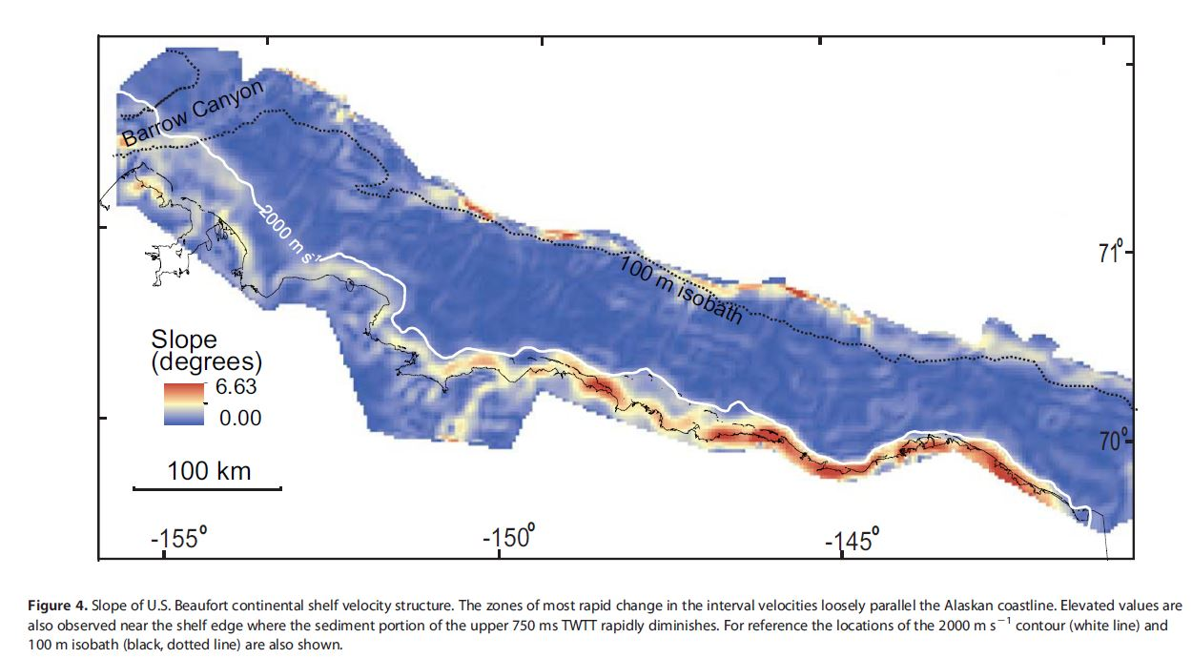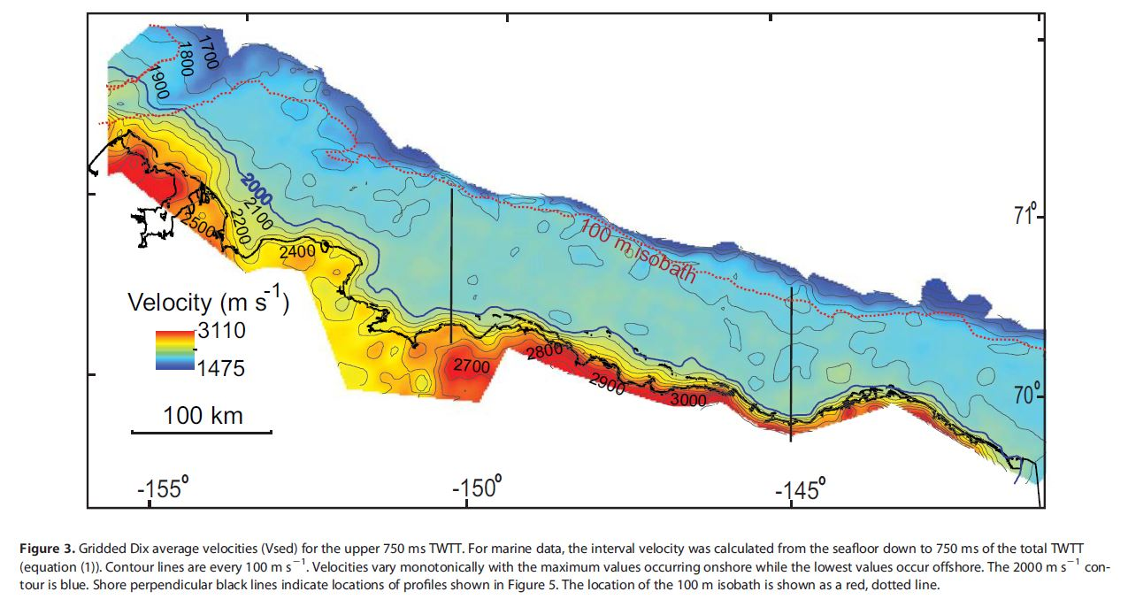

Les données recueillies sont meilleures pour le littoral que la mer.

Les vitesses les plus rapides concordent avec les épaisseurs apparentes.

La hauteur d’eau impact sur les vélocités mesurées.

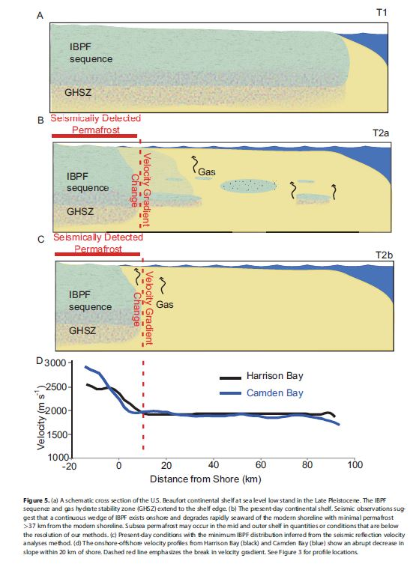

Portnov et al. [2013] suggest that continuous subsea permafrost acts as a seal for gas sourced below the permafrost (e.g., from gas hydrate or deeper thermogenic sources) and with degradation gas migrates up along the seaward edge of continuous subsea permafrost. Both the Canadian Beaufort and the West Kara shelves host pingo-like features associated with seabed fluid escape [Paull et al., 2007; Portnov et al., 2013; Serov et al., 2015]. Though neither pingo-like features nor seafloor degassing have ever been observed on the U.S. Beaufort, we suggest that the vicinity of the 2000 m s21 contour is the locus at which degassing related to IBPF degradation is most likely to occur.

Using the stacking velocities from 100,000 km of industry seismic data, we infer that the continuous IBPF sequence exists close to shore along the entire extent of the U.S. Beaufort margin and thins rapidly seaward.

The interpreted seaward edge of this continuous IBPF, the 2000 m s21 contour, is everywhere at contemporary water depths of less than 25 m, and within 37 km of the modern shoreline. Our method produces a shelf-scale map of minimum areal distribution of ice-bearing permafrost. Seaward of the continuous IBPF, permafrost or relict IBPF may exist in small quantities. Our results show that U.S. Beaufort subsea permafrost has degraded substantially since Pleistocene lowstand and, when taken into account with other regional observations, the shelf-edge should be dismissed as the presumed extent of continuous IBPF.

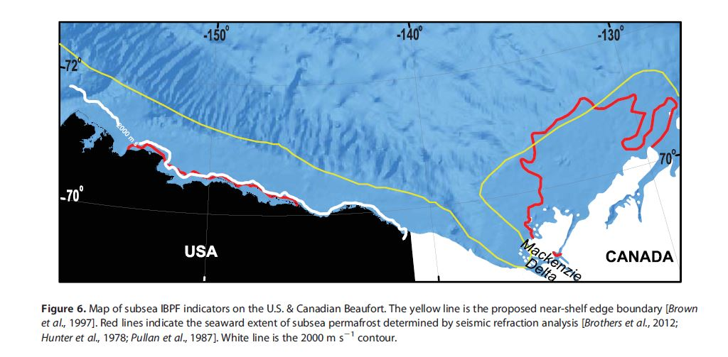

A rock-physics investigation of unconsolidated saline permafrost: P-wave

properties from laboratory ultrasonic measurements

Le pergélisol est partiellement gelée lorsqu’il y a du sel dans l’eau en raison du point eutectique de -21 degrés du sel. Il peut y avoir du dégel du pergélisol salé sous des températures inférieures à 0 degré. Le pergélisol est aussi moins résistant lorsqu’il est salé.

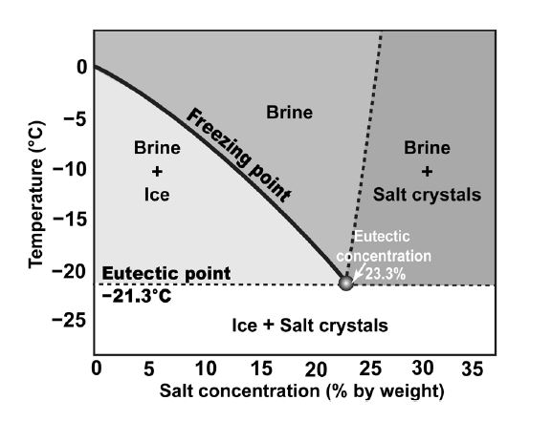

Mechanisms for unfrozen water to remain liquid below freezing

1. Dissolved salt
2. Surface effects : Capillary, adsorption,
3. Super cooling

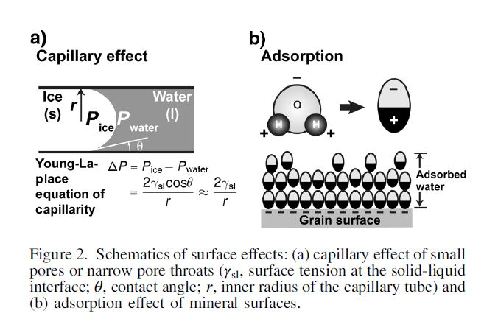

Supercooling of a liquid is the maintenance of its liquid state below the freezing point. For porous sediments, supercooling mainly affects the free water (Andersland and Ladanyi, 2004). Supercooled water is metastable. If the temperature gets low enough, or if ice microparticles grow sufficiently large to facilitate nucleation, the supercooled water freezes spontaneously and rapidly.

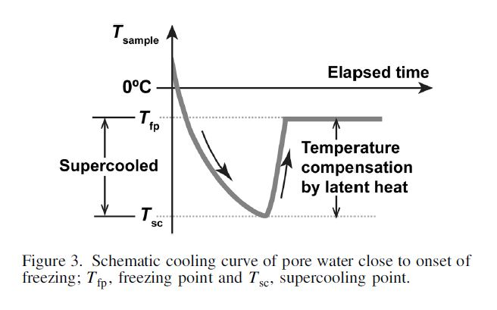

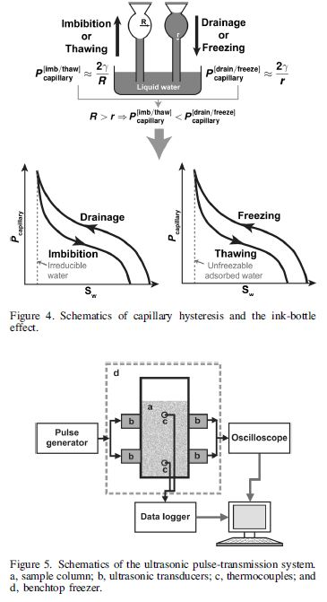

The first cycle of the waveform arrives at successively earlier times as the temperature decreases, illustrating the monotonic increases in the P-wave velocities. By contrast, the associated changes in the spectral contents do not show such monotonicity. Instead, the high-frequency contents of the spectra first diminish at temperatures that are immediately below the freezing point (e.g., −2.3°C and −3.5°C in Figure 7), and then they gradually grow back as the temperatures decrease further (e.g., Rock physics of saline permafrost WA237

−12.6°C in Figure 7). In the end, when the temperatures are below the eutectic point (e.g., −25.6°C in Figure 7) the waveforms become impulsive and compact, and the spectra include a considerable amount of higher frequencies.

On observe une baisse important de l’amplitude des ondes P lorsque la temperature atteint le point eutectique de -21.3 degrés. Cette baisse s’observe peu importe la teneur en sel dans l’eau des pores de l’échantillon de sol. Lorsqu’il n’y a pas de sel dans l’eau, la baisse d’amplitude est seulement fonction de la température lorsqu’elle atteint 0 degré.

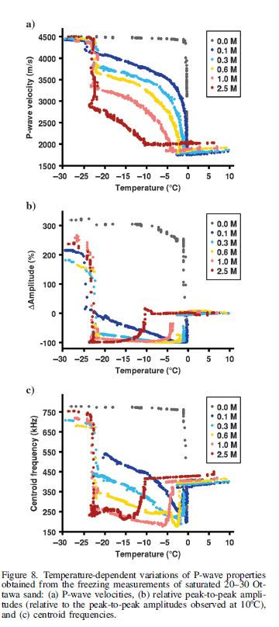

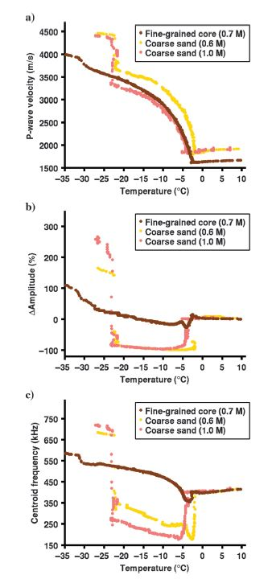

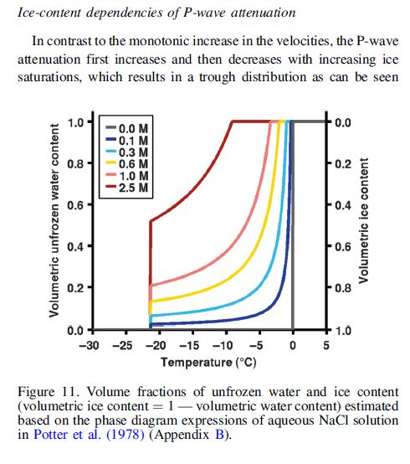

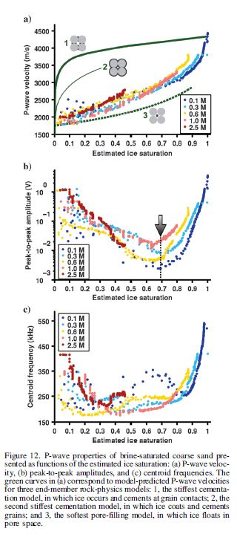

An effective-medium model for P-wave velocities of saturated, unconsolidated saline permafrost

The most striking characteristic that distinguishes saline permafrost from its nonsaline counterpart is its heightened temperature sensitivity. Unlike nonsaline permafrost that is generally stable unless its temperature approaches 0°C, saline permafrost is highly responsive to warming even at temperatures that are well below 0°C (Ruffell et al., 1990). This is attributed to two effects of the dissolved salts: (1) freezing-point depression and (2) progressive salination of the residual pore water. In the latter process, the residual pore water become more saline because salts are excluded from ice (known as the freeze desalination process that results from the inability of ice crystals to accommodate salts). Such salination further lowers the freezing point of the residual water and consequently slows down freezing. As a result, saline permafrost usually takes the form of a partially frozen “slush,” in which ice and brine coexist in a delicate equilibrium that can be easily perturbed.

Prior permafrost studies have shown that increases in ice content generally coincide with increases in mechanical strengths and seismic velocities (Timur, 1968; Nakano

and Froula, 1973; Zimmerman and King, 1986). Containing less ice, saline permafrost can be identified as low-velocity anomalies that stand out against a background of nonsaline permafrost (Collett and Bird, 1988, 1993; Schmitt et al., 2005; Hubbard et al., 2013; Dou and

Ajo-Franklin, 2014).

To analyze these data sets using established rock-physics relationships between VP and ice saturation si (si ¼ Volice∕Volpore: volume fraction of the total pore space occupied by ice), we need to convert the temperature measurements into the corresponding ice saturations (hereinafter referred to as T-to-si conversion).

Determining freezing point Tfp (in °C) for a given initial salinity Sn0 (in wt%; Sn0 ¼ SnjT∈T½af _, where T½af_ denotes the above-freezing temperature T½af_ Tfp):

Tfp = 0.00 – (0.5818555Sn0 + 3.48896 × 10−3S2 n0 + 4.314 × 10−4S3 ): (1)

• Determining equilibrium salinity SnEQ (in wt%; SnEQ = SnjT∈T½pf_ ) at a given temperature in the partially frozen regime (in °C; T ∈ T½pf_, where Teutectic < T½pf_ < Tfp):

SnEQ jT∈T½pf_ = 1.76958|T| −4.2384 ×10−2|T|2 + 5.2778×10−4|T|3: (2)

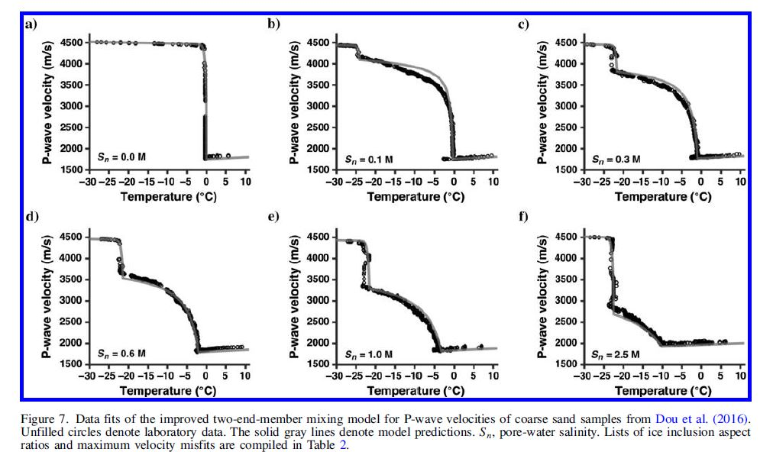

Activation of old carbon by erosion of coastal and subsea permafrost in Arctic Siberia

Arctic permafrost can be divided into three main compartments: terrestrial (tundra and taiga) permafrost (,1,000 Pg C)8, Ice Complex (coastal and inland) permafrost (,400 Pg C)4,8 and subsea permafrost (,1,400 Pg C)6,

To evaluate the role of the ICD and subsea permafrost carbon (hereafter jointly referred to as ICD-PF) in the contemporary ESAS carbon cycle, we adopted an inverse approach based on deducing the contribution of this ICD-PF to carbon accumulating on the entire ESAS

shelf.

**2017 Korea-Canada-U.S.A. Beaufort Sea (offshore Yukon and Northwest Territories) research program: 2017 *Araon* expedition (ARA08C) cruise report**

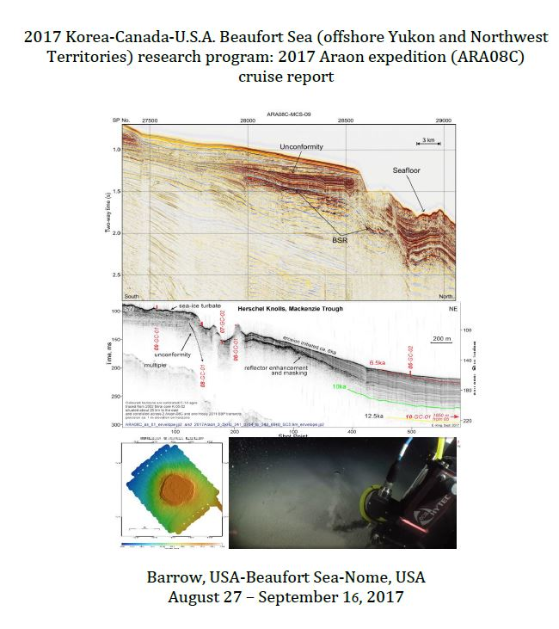

Explication brève de la procedure:

The expedition focused on two main research areas in the Canadian Beaufort Sea: the

Mackenzie Trough and its western shelf and slope area (Yukon continental margin) from

August 29 to September 7, and the Beaufort shelf and slope areas to the east of Mackenzie

Trough from September 8 to September 12 (Figure S1).

During five days (from 31 August to 4 September), multichannel seismic (MCS) data on

12 lines were collected in the Mackenzie Trough and the Yukon Shelf using airgun array

comprised of two Sercel Generator-Injector (G.I.) airguns. The total survey length was about

890 line-km with 35,496 shot gathers including test and transit lines (Figure S1).

Line de tir sismique et tous les profils réalisés:

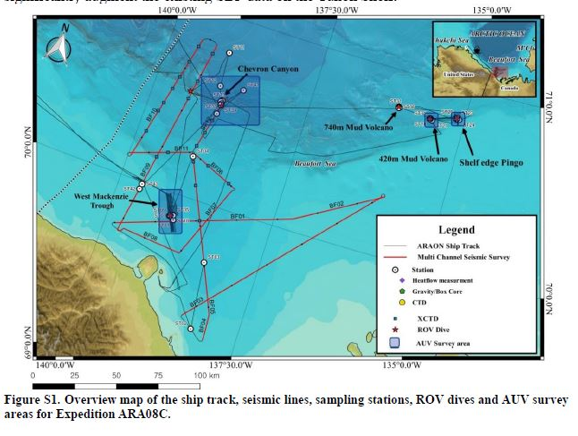

Description de la géologie en place : Important

**1.2. Geologic Setting**

The shelf of the Canadian Beaufort Sea is underlain by thick terrestrial permafrost which has been inundated by relatively warm seawater as a consequence of post-glacial sea level rise.

As described by Taylor et al. (2013) the permafrost body beneath the shelf extends far offshore pinching out at the shelf–slope break at approximately 100 m water depth. Gas hydrates, a solid form of natural gas wherein water molecules are arranged in a cage-like structure with methane

(or occasionally other gases) are also found in this setting. Gas hydrates are unstable at atmospheric pressure and temperature, decomposing spontaneously into gas and water. Gas hydrates exist beneath the Beaufort Sea in two locales: conventionally in deep water (slope and basin) where pressure of more than 30 atmospheres provides stability, and as permafrost gas hydrate in shallow water over the continental shelf where low formation temperatures can maintain their stability at somewhat shallower depths. Geothermal modeling by Taylor et al.

(2013) suggests that gas hydrates do not occur between the outer edge of subsea permafrost

(~110 m water depth) and approximately 300 m water depth.

Warming and possible thawing of the permafrost and dissociation of permafrost gas hydrate as a consequence of the sea level rise may weaken subsurface sediments and lead to subsidence, reduction of sediment strength and release of free gas. Field studies, including those from

CCGS Sir Wilfrid Laurier in 2003, 2010 and 2012, 2013, 2016 have documented the escape of methane from the seabed of the outer shelf and slope. Gas venting has been observed from

6 some conical mounds on the shelf which are referred to as pingo-like features (Paull et al.,

2007). Gas venting has also been observed from an area of large landslides at top of the continental slope near 100 m depth and from the upper slope associated with large conical features that appear similar to mud volcanoes described in other settings around the world. We propose that degrading permafrost and gas hydrates liberate gas and pore water that reduce the strength of subsurface sediments, leading to possible seabed instability.

Schéma des propriétés des tirs ainsi que le schéma de l’expérience réalisée :

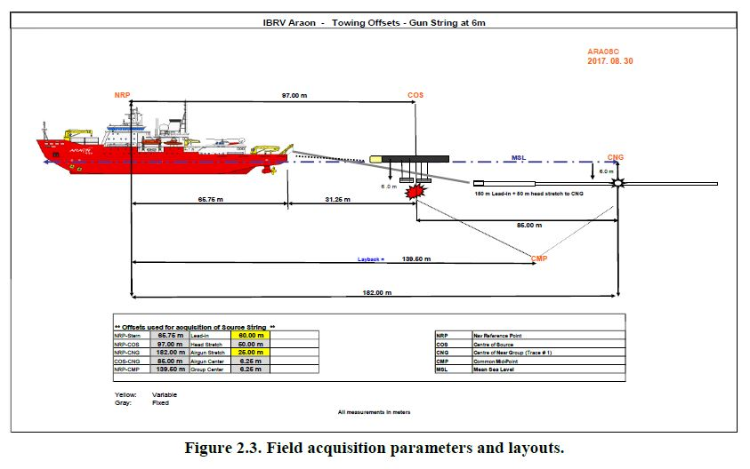

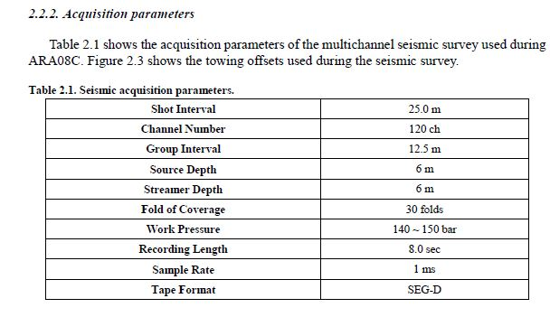

Numéro des tirs :

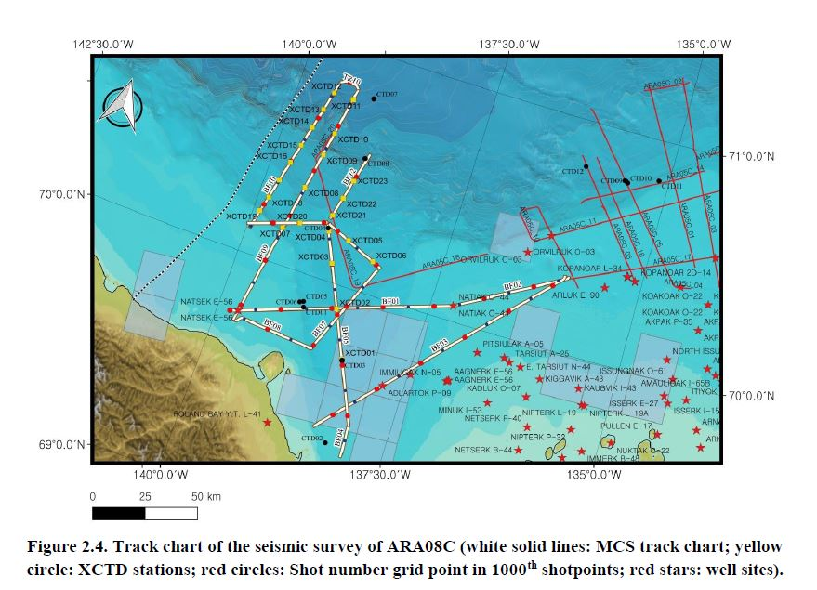

Multibeam survey :

Zones étudiées plus précisément :

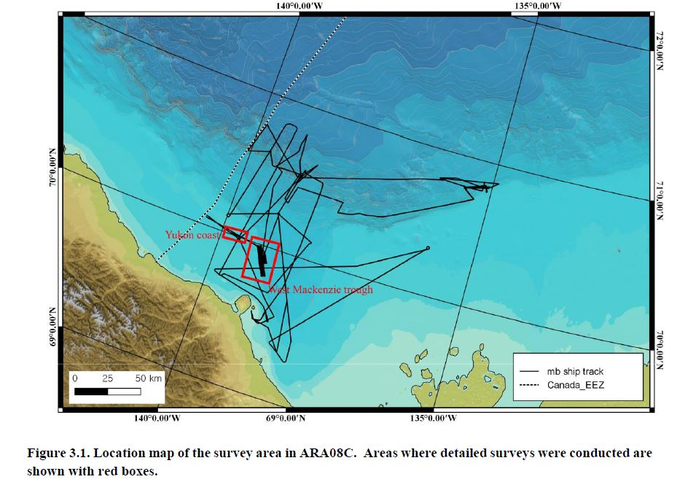

***3.3.1. Detailed survey of Western edge of Mackenzie Trough***

The Western Mackenzie Trough has very limited seafloor-mapping information. We conducted a targeted multibeam survey in this area with survey lines of ~20 km in length trending in a northwest-southeast direction. Water depths of the survey area ranged from ~70 m to ~180 m. We identified two primary targets, a narrow trough aligned sub-parallel to the survey lines and several possible Pingo-Like Features (PLF) with heights of ~10 m and widths of ~20 m (Figure 3.3). The multibeam data collected during this survey formed the base data for the subsequent Autonomous Underwater Vehicle (AUV) survey (see Chapter 5).

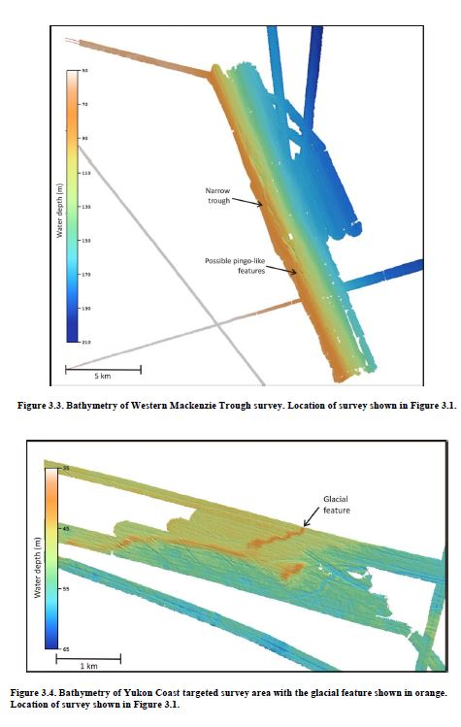

Les résultats de tirs sismiques à l’embouchure du creux de Mackenzie sont illustrées à la figure suivante : Les numéros de référence sur la carte sont illustrées plus haut dans le document de référence.

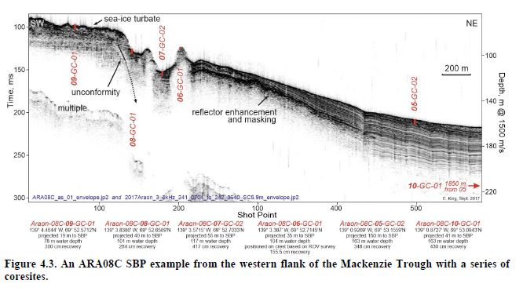

Le creux de Mackenzie est recouvert en partie par des dépôts post-glaciaire qui font une épaisseur de 40 à 80 mètres. C’est dans cette région que les dépôts, lors du retrait des glaciers, ce sont déposés.

Un véhicule sous-marin a été utilisé ayant pour objectif de marquer la topographie sous-marine de la mer de Beaufort. Le volcan de boue ainsi qu’une grande partie du territoire a été cartographié pour pouvoir mieux comprendre cette dite topographie.

Un second véhicule a été utilisé dans l’objectif de prendre des échantillons, des photos ainsi que d’explorer les fonds sous-marins de la mer de Beaufort.

La mesure des flux de chaleur a été faite aussi.

Seismic stratigraphy, sedimentary architecture and palaeo-glaciology of the

Mackenzie Trough: evidence for two Quaternary ice advances and limited fan development on the western Canadian Beaufort Sea margin

The Mackenzie Trough on the western Canadian Beaufort Sea margin is a 150 km-long, partially-infilled linear depression, which extends in a NNW direction from the modern Mackenzie River Delta to the continental shelf break at around 800 m below present sea level (Fig. 1B and C).